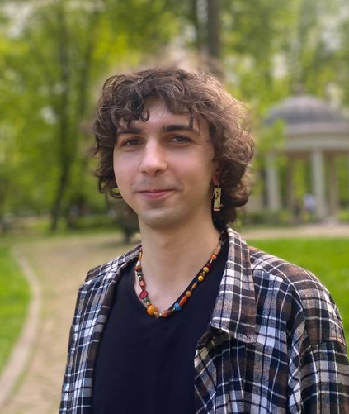
Curriculum Vitae
Maksimu Andre Martynenko Shchehlov

Email: fruttto@yahoo.com
Mobile: +380994901655
Telegram: @aFruta

Education

Ivan Franko National University of Lviv
Slavic languages and literatures (including translation),
2021–2025
Serbian is the first language, bachelor’s degree

Projects

Bosnian to Ukrainian film translation (subtitles) for Filma (feminist film festival)
2024

Participation in CELA (Connecting Emerging Literary Artists), a program for emerging writers and translators. Translating excerpts from 3 books written by Serbian authors Ljiljana Ćuk, Nikola Lekić and Filip Grujić
CELA website
2024–2028

Literary translation of a collection of short stories «Uslovi nisu bitni» by Ljiljana Ćuk for a publishing house “Hrushka”
2025

Additional education
Seminar of Serbian language, literature and culture in Belgrade, Novi Sad, Tršić
2024

Language skills
Ukrainian — native
Serbian/Bosnian/Montenegrin, Croatian, English — B2
Bulgarian — A2

Additional skills
Adobe Photoshop/Illustrator (Affinity Photo/Designer), Excel, Word

