ANASTASIIA KOVALENKO

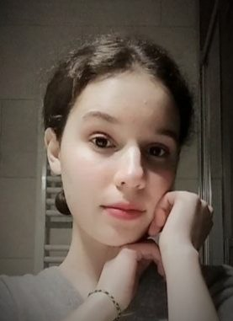

TRANSLATORLocation icon KYIV, SAPORISCHSCHJA UKRAINE

105690295 +380684033941

**○ PERSONAL DETAILS ○**

KYIV, SAPORISCHSCHJA

UKRAINE

+380684033941

[natya.kovalenko1@gmail.com](mailto:natya.kovalenko1@gmail.com)

Date of birth:

21.08.2005

Nationality:

Ukrainian

**SOCIAL NETWORKS** VIBER

TELEGRAM

(+380684033941)

**○ SKILLS ○**

CREATIVITY

CRITICAL THINKING

COMPUTER SKILLS

MICROSOFT OFFICE

ABILITY TO WORK IN TEAMS

ADAPTABILITY

COMMUNICATION SKILLS

ABILITY TO WORK UNDER PRESSURE

FAST LEARNER

FAMILIAR WITH CAT-TOOLS

**https://cdn-icons-png.flaticon.com/512/1077/1077114.png PROFILE**

I am beginner translator. My mother tongue is Ukrainian. I am studying translation at university. I work with Ukrainian-English and Ukrainian-German language pairs. At the moment I teach English to children.

* **WORK EXPERIENCE**

Englisch tutor für Kinder auf der BUKI-Plattform (September 2023 – laufend)

* **EDUCATION**

I have completed 11 classes of school № 98 in Zaporizhzhya September 2011 – May 2022

Now I am a student of Mykhailo Drahomanov Ukrainian State University in Kyiv. Subject of study - English and German translation.

Published translations made with my participation:

<https://md-eksperiment.org/post/20240221-chuzhyna-chy-ridnyj-kraj-naskilky-stijkoju-ye-nasha-mova>

<https://md-eksperiment.org/post/20240106-vona-she-j-zhartuye-pro-smishnih-zhinok-u-pop-kulturi>

<https://md-eksperiment.org/post/20231110-nacionalni-parki-nimechchini-podorozhi-dikoyu-prirodoyu>

<https://md-eksperiment.org/post/20231012-pershi-kitajski-perekladachi-tvoriv-dzhejn-ostin>

<https://md-eksperiment.org/post/20231011-yak-poyasniti-dityam-sho-take-yevropa>

<https://md-eksperiment.org/post/20230927-samoocinka>

<https://md-eksperiment.org/post/20240604-riznomanittja-v-povsjakdennomu-pedahohichnomu-zhytti-nimechchyny>

<https://md-eksperiment.org/post/20240502-oserdja-nasylstva-retsenzija-na-knyzhku-sofi-oksanen-vijna-putina-proty-zhinok>

<https://md-eksperiment.org/post/20240510-dyskryminatsija-shkodyt-naukovomu-prohresu-interv-ju-z-ketryn-gejmans>