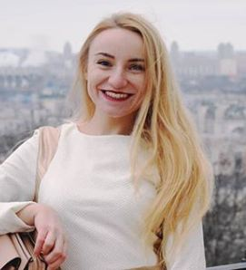
Curriculum vitae
Personal details
Yaryna Karkhut
Kyiv, Ukraine
Phone number +380671666269
Experience in translation
2 years
Email: jarunochka96@gmail.com Education
2017-2018 Master Degree in Translation,
National Pedagogical Dragomanov
University
2015 FCE courses with Americans. Diploma C1/2 level in English
2013 – 2017 Bachelor Degree in Translation,
National Pedagogical Dragomanov University
Professional experience
2019 April - 2020 April Visa365, Leading translator
December, 2018- December 2019 Transparency International Ukraine
Translator
Skills
- Communication
- Editing
- Flexibility
- Decision Making
- Leadership
- Strategic Planning
IT – Office 2010, Excel, PowerPoint Languages: Advanced English
Polish Beginner A1 German А1/2 Russian
Awards
I was awarded the first prize at journalistic competition of «Spravy simeini» magazine.
I took first place in patriotic literature competition "WAR IN UKRAINE-2017"
Activities
Travelling (I have visited 9 countries)
Poland, Germany, Netherlands, Spain, Montenegro, Serbia, Portugal, Bulgaria, France
November, 2016 Volunteering company Helpx, Hitzacker Germany
References
David Feldbruger – host in Germany http://www.helpx.net/profile.asp? usercode=1384626JB
Роман Климчук – директор ФОП компанії Віза365
+38093 745 4595

