- Personal Information
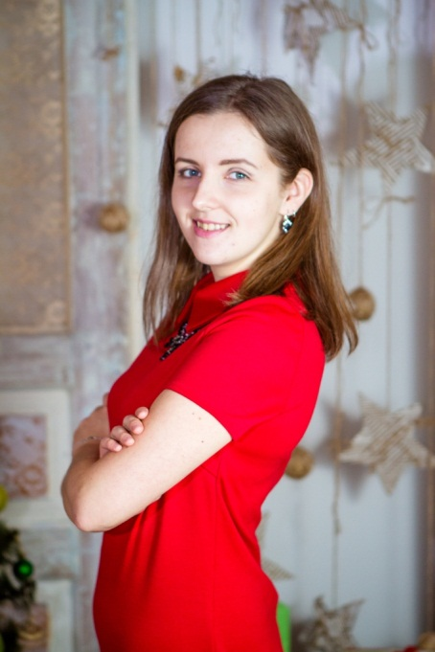
Name: Hanna Zvonok
Address: 136/22 Prylutska, Nizhyn, 16612, Ukraine
Phone number: +380673255770
Marital status: single
Date of Birth: 5th January 1994
Email: annazvonok@gmail.com

- Education
Nizhyn Mykola Gogol State University
Foreign Languages Department
Specialist’s Degree in Teaching of English and German Languages and Foreign Literature
2011-2016

- Qualifications
“Start writing fiction” course at The Open University in 2019, 5th February
“What is good writing” course at The Open University in 2019, 8th February
“Writing what you know” course at The Open University in 2019, 8th February.

- Work experience
“Step by Step” Development Centre (language courses) 11/03/2019 – present
- Conducting lessons
- Checking homework
- Preparing for the lessons, tests
- Conducting extracurricular activities
- Analyzing students’ progress
- Contacting with parents
- Making suitable schedule.

- Personal Qualities
Enduring, diligent, creative, always work to achieve the goal, never stand on the same place, know what I want from life, always set new goals and move on, develop personal qualities and myself.

- Special skills
- Languages: English – advanced, German – elementary, Russian – freely, Ukrainian – native
- Hobbies: writing fiction, reading, music, travelling, cooking.

- Publications
Book:
- Nova Rasa / H. M. Zvonok. – Vinnytsia : TOV “Nilan-LTD”, 2018. – 184p. ISBN 978-966-924-776-6
Periodical Journals:

- Zvonok, Hanna. “Free Personality,” Dzvin 9 (887): 161-162
- Zvonok, Hanna. “Dream,” Dzvin 9 (887): 162
- Zvonok, Hanna. “Act!” Dzvin 9 (887): 162-163
- Zvonok, Hanna. “Personality,” Dzvin 9 (887): 163-169
- Zvonok, Hanna. “Home,” Dzvin 9 (887): 169

