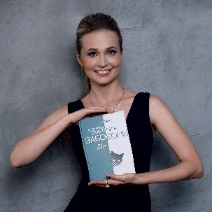 | Iryna  Malevych  +38 (093) 503-40-70  iryna.malevych@gmail.com  www.linkedin.com/in/imalevych
Profile | A full-time freelance Finnish-Ukrainian literary translator with 11+ years’ experience living in Odesa, Ukraine
Education | MA in Finnish and English languages  Kyiv National Linguistic University  Graduated with honors  Visiting student  Major in Finnish language and culture  University of Helsinki | 2013  2013
Honors-Awards | Honors in Finnish and English language  Best Oral Presentation Award | 2013  2012
Professional  development | Non-fiction editing course  Fiction editing course  Non-fiction translation course  Fellowship program for translators of Finnish literature  Helsinki, Finland  Ukrainian Translation Industry Conference  XI Translation and interpreting symposium  ”Technology and Translator’s Work”  Turku, Finland  Translation Industry Professionals Interpreter seminar  Finnish contemporary literature course  International conference “NITE ІV.  Names and Cultures in a Commercial Environment"  Turku, Finland  Suomea Suomessa training program  Villa Porkkala -pienryhmäkoti, Hanko, Finland  Intensive summer courses in Finnish language and culture  Oulu, Finland | 2020  2020  2018  2018  2013  2013  2013  2012  2012  2011  2010
Residencies | Translator-in-residence program  Villa Salin, Helsinki, Finland | 2018
Grants | Translation grant for Memento mori by Tiitu Takalo into Ukrainian  Translation grant for Tervetuloa kotiin, Helmi, Helmin elämää, Helmi, perhosemme by Tuula Pere into Ukrainian  Translation grant for Ettekö te tiedä, kuka minä olen by Ari Turunen into Ukrainian  Translation grant for Hyvän ja pahan merkit eli taikauskoisten tapojen tarina by Ari Turunen into Ukrainian  Translation grant for Humalan henki eli juomatapojen tarina by Ari Turunen into Ukrainian  Translation grant for Onnellisuuden opas by Timo Airaksinen into Ukrainian | 2021  2020  2019  2018  2017  2015
Panels-Appearances | Meeting with Tuula Pere  Publishing center “12”, Institute of Ukrainian Studies, Ukrainian Cultural Foundation, Sensoteca  Translator meeting  House of Science and Letters, Helsinki, Finland | 2020  2018
Interests | Visual arts, paragliding, yoga

